**Bug Report**

**Website : Demoblaze.com**

**Sami Ullah : 4079**

|  |  |  |
| --- | --- | --- |
| **Category** | **Label** | **Value** |
| Bug Id | Bug id | BI01 |
| Name | Navbar is not visible properly at small screen when any product is viewed |
| Reporter | Sami Ullah |
| Date | 25/07/2022 |
| Bug Overview | Summary | When a product is open on smaller display navigation bar appearance affected. |
| URL | https://demoblaze.com/prod.html?idp_=1 |
| Screenshot |  |
| Environment | Platform | Windows 10 |
| Operating System |  |
| Browser | Version 103.0.5060.134 (Official Build) (32-bit) |
| Bug Details | Steps to Reproduce | 1. Visit demoblaze.com 2. Adjust screen size to small 3. Open any product |
| Expected Result | Navigation bar must appear with propery margin between product and itself |
| Actual Result | No margin is given between navigation bar and product so user interface is not working properly |
| Description |  |
| Bug Tracking | Severity | High |
| Assigned to |  |
| Priority | High |
| Notes | Notes |  |

|  |  |  |
| --- | --- | --- |
| **Category** | **Label** | **Value** |
| Bug Id | Bug id | BI02 |
| Name | Order is placed with empty cart |
| Reporter | Sami Ullah |
| Date | 25/07/2022 |
| Bug Overview | Summary | Demoblaze.com places order even if cart doesnot contain any item in it. |
| URL | https://demoblaze.com/cart.html |
| Screenshot | Provided below |
| Environment | Platform | Windows |
| Operating System |  |
| Browser | Version 103.0.5060.134 (Official Build) (32-bit) |
| Bug Details | Steps to Reproduce | 1. Goto demoblaze.com 2. Click on cart 3. Click on place order with out adding any product 4. Fill form 5. Order is placed. |
| Expected Result | Error message regarding cart is empty should be displayed |
| Actual Result | Order is placed. |
| Description |  |
| Bug Tracking | Severity | High |
| Assigned to |  |
| Priority | High |
| Notes | Notes |  |

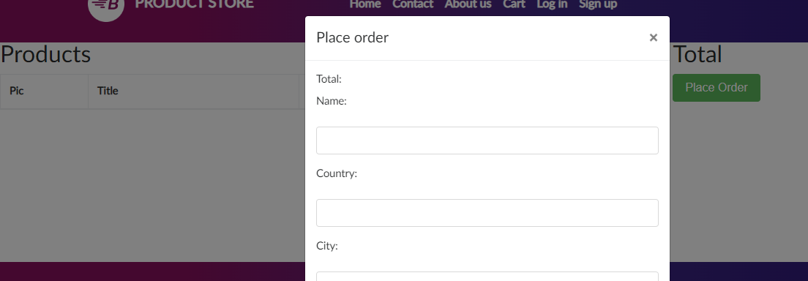

|  |  |  |
| --- | --- | --- |
| **Category** | **Label** | **Value** |
| Bug Id | Bug id | BI03 |
| Name | No tracking is available for guest customer after placing order without signing up. |
| Reporter | Sami Ullah |
| Date | 25/07/2022 |
| Bug Overview | Summary | When a user visits as a guest and place an order with out signing up, order is placed successfully but unable to trace its status. |
| URL | https://demoblaze.com/cart.html |
| Screenshot | No available |
| Environment | Platform | Windows |
| Operating System |  |
| Browser | Version 103.0.5060.134 (Official Build) (32-bit) |
| Bug Details | Steps to Reproduce | 1. Goto demoblaze.com 2. Add product in cart without sign in 3. Click place order 4. Fill form 5. Click ok 6. Order is placed |
| Expected Result | It should allow guest user to track its order status. |
| Actual Result | Guest user is not facilitated with this feature. |
| Description |  |
| Bug Tracking | Severity | High |
| Assigned to |  |
| Priority | High |
| Notes | Notes |  |

|  |  |  |
| --- | --- | --- |
| **Category** | **Label** | **Value** |
| Bug Id | Bug id | BI04 |
| Name | Sign up page fields has no validation criteria |
| Reporter | Sami Ullah |
| Date | 25/07/2022 |
| Bug Overview | Summary | The sign up provided to register a user does not contain any validation and is accepting any form of data to register a user successfuly. |
| URL | https://demoblaze.com |
| Screenshot | Provided below |
| Environment | Platform | Windows |
| Operating System |  |
| Browser | Version 103.0.5060.134 (Official Build) (32-bit) |
| Bug Details | Steps to Reproduce | 1. Visit demoblaze.com 2. Click on Sign up page 3. Fill name and password 4. Click sign up |
| Expected Result | System should ask for valid credentials |
| Actual Result | System doesnot ask for valid credentials and register user. |
| Description |  |
| Bug Tracking | Severity | High |
| Assigned to |  |
| Priority | High |
| Notes | Notes |  |

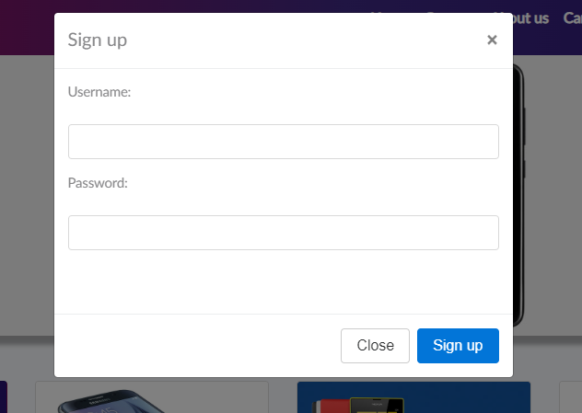

|  |  |  |
| --- | --- | --- |
| **Category** | **Label** | **Value** |
| Bug Id | Bug id | BI05 |
| Name | User is unable to access profile page |
| Reporter | Sami Ullah |
| Date | 25/07/2022 |
| Bug Overview | Summary | When user successfully registers and place order, he is unable to visit profile page inorder to track his order.  Link is static |
| URL | https://demoblaze.com/index.html# |
| Screenshot | Provided below |
| Environment | Platform | Windows |
| Operating System |  |
| Browser | Version 103.0.5060.134 (Official Build) (32-bit) |
| Bug Details | Steps to Reproduce | 1. Sign in to demoblaze.com 2. Click on Welcome Sami4 |
| Expected Result | User profile page must be opened |
| Actual Result | No profile page is accessed |
| Description |  |
| Bug Tracking | Severity | High |
| Assigned to |  |
| Priority | High |
| Notes | Notes |  |

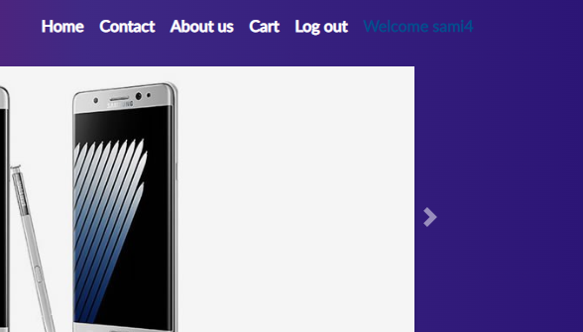

|  |  |  |
| --- | --- | --- |
| **Category** | **Label** | **Value** |
| Bug Id | Bug id | BI06 |
| Name | Contact us form is submitting empty fields |
| Reporter | Sami Ullah |
| Date | 25/07/2022 |
| Bug Overview | Summary | Contact us form is missing fields validation. Contact us form is generating success message even if empty fields are submit. |
| URL | https://demoblaze.com/index.html |
| Screenshot | Provided below |
| Environment | Platform | Windows |
| Operating System |  |
| Browser | Version 103.0.5060.134 (Official Build) (32-bit) |
| Bug Details | Steps to Reproduce | 1. Goto demoblaze.com 2. Click on contact us link 3. Left fields empty 4. Click Send Message |
| Expected Result | Message with empty fields should not be send |
| Actual Result | Message success alert is generated and message is sent |
| Description |  |
| Bug Tracking | Severity | High |
| Assigned to |  |
| Priority | Low |
| Notes | Notes |  |

